**APPLICATION OF HELMET MOUNTED RADAR TECHNOLOGY IN MILITARY OPERATION**

**JOHNSON VAHELLA JAMES**

**(ST/CS/ND/20/398)**

**A SEMINAR REPRESENTED TO THE DEPARTMENT OF COMPUTER SCIENCE, SCHOOL OF SCIENCE AND TECHNOLOGY, FEDERAL POLYTECHNIC MUBI, ADAMAWA STATE, NIGERIA**

**NOVEMBER, 2022**

**APPLICATION OF HELMET MOUNTED RADAR TECHNOLOGY IN MILITARY OPERATION**

**JOHNSON VAHELLA JAMES**

**(ST/CS/ND/20/398)**

**A SEMINAR REPRESENTED TO THE DEPARTMENT OF COMPUTER SCIENCE, SCHOOL OF SCIENCE AND TECHNOLOGY, FEDERAL POLYTECHNIC MUBI, ADAMAWA STATE, NIGERIA**

**IN PARTIAL FULFILLMENT OF THE REQUIREMENTS FOR THE AWARD OF NATIONAL DIPLOMA (ND) IN COMPUTER SCIENCE**

**NOVEMBER, 2022**

**Abstract**

*Soldiers are very essential part of any nation’s security system. During, wars and search operations soldiers get injured and some of them go missing. As we all know soldier’s health is important because they are the savior of our country who protects us from terrorist attacks and from many suspicious activities which can harm us and our nation too. This project will give an ability to track the location and monitor health of the soldiers in real time which goes missing at battlefield. It will minimize the time and rescue operation efforts of army control unit. It will help the army base station to track the location and monitor health of soldiers using GPS module and sensor such as temperature sensor, heart beat sensor, etc. The data coming from sensors and GPS receiver is transmitted wirelessly using Zigbee module having the range of 10 to 100m. A soldier can ask for help from control room using a panic switch and we have also used RADAR which will alert the soldier using vibrator within the range of 3cm to 4m.*

**Keywords:** Security system, Radar, Helmet, Global Positioning system.

**Introduction**

In today’s word, the science and technology are growing rapidly with new inventions, innovations and with advance level of their implementations. These advance technologies are adopted by defense services for safety purpose of our soldiers. The system proposed by us composed of two parts, one is small and portable unit for soldiers and other is for army control unit. The soldier’s unit consists of an ATmega16 Microcontroller, GPS tracking device, Zigbee transceiver, heart beat sensor, temperature sensor, etc. With the help of satellite communication system GPS device is use to track the location of the soldiers. The heart beat sensor is use to sense the pulses or heart beats of human heart, and temperature sensor is used to sense the temperature of human body. All the processed and sensed data are transmitted wirelessly through a Zigbee module, which having low power, low data rate transceiver used to transmit and receive the data (Adam, 2014).

Helmet Mounted Radar System (HMRS), is a device designed to help soldiers recognize threats within their immediate vicinity. Able to detect moving targets with a full 360 degrees field of view, the radar can catch potential enemies at distances of up to 80 feet.  Of course, the Moving Target Indicator (MTI) will turn up everything that moves, so soldiers will probably end up being freaked out by benign woodland creatures.  Sounds like a fun accident waiting to happen (Allison et al., 2009).

The HMRS uses an Advanced Combat Helmet with the necessary sensors and electronics all fitted into it (both mounted and embedded).  It can see through fog, smoke, dust and pitch-black environments, making it ideal for use in fields of battle.  The entire assembly will weigh around 2.5lbs, which should be comfortable enough to wear on your head. If you’re worried enough by cellphone radiation emissions, putting a powerful radar on your head will probably freak you out even worse.  At least, when soldiers begin suffering from brain tumors, we’ll all have something obvious to blame. Sources say the project is not ambitious as it seems, given that similar, less powerful prototypes have been made in the past.  Regardless, don’t expect to see them in-field (or use them to sniff out your stalkers) within the next few years (Brickner & Foyle, 2009).

Radar can see through fog, smoke and dust, and works just as well in pitch darkness. Which could make it pretty useful for catching creeping adversaries. The HMRS might also have some other useful features; the ability to see through foliage, and the ability to see through walls, are described as "desired" capabilities for the HMRS rather than requirements. The HMRS description also encouragingly specifies that "the effective radiated power of the system has to be low enough not to affect the health of the soldier" -– and presumably not the other members of the squad either, who are likely to be lit up by each other's radar from all directions. Anyone worried by [cellphone radiation emissions](http://www.cellphonesafety.org/health/) need not apply, tinfoil helmet liners optional. The whole system should weigh less than two and a half pounds, with less than a pound of that being mounted on the helmet. This is not as ambitious at it might sound; a few years ago, ImSAR and Insitu developed a Micro Miniature Synthetic Aperture Radar weighing two pounds called [NanoSAR](http://www.imsar.com/" \t "_blank). It included a Moving Target Indicator. NanoSAR has [a range of over a kilometer](http://www.imsar.com/NanoSAR%20Flyer_03_08.pdf), but its fifteen-watt power consumption would eat up batteries if left on continuously (Amitai et al., 2008).

And that's just one of the many questions about how the radar will work in practice. As well as 360-degree horizontal coverage, what's the vertical? If you tilt your head up or down do you lose coverage? There is also the question of how the system should pass on information to the user, which should be answered in the Phase I part of the project. Something like a heads-up display might be too much to cope with; but perhaps an audible tone or a simple LED display might be all that's needed. The HMRS will be constantly set off by friendly troops, who are likely to be nearer than the enemy. And it might also be triggered by any number of other moving objects, such as tree limbs blowing in the wind. Development is likely to take several years, and it may end up as another one of those useless additional weights that nobody wants to carry around but it might just turn out to be a life-saver (Benson & Barnes, 2008).

Radar indicators and displays are used to present the information contained in the radar return signal in a format suitable for operator interpretation. The display may be connected directly to the video output of the radar receiver. Radars that provide information at a greater rate than an operator can assimilate, however, normally use automatic data processors to interpret and condense the radar receiver output. In that event, only the condensed information is displayed. I The radar display is usually a two-dimensional screen that shows the target locations with respect to some reference point. It can, however, assume some other form, such as a light to indicate a status or condition, or a meter to indicate the value of some parameter such as antenna pointing angle or range to a particular target. A numerical readout is another example of a radar display; it may indicate the range, bearing, or speed of a particular target or the status of a radar function. The information is typically presented on a screen for direct viewing by the operator. In applications where direct viewing is not practical, the operator may view a virtual image, as is the case with lens-aided displays, such as those which are helmet mounted, and head-up displays (HUDs) that project images onto a glass screen in the operator's field of view (Rash et al., 2013).

**Literature Review**

Military applications for helmet-mounted displays (HMDs) have exploded in the past decade. Originally conceived for aviation, HMDs have been developed for an expanding array of mounted and dismounted applications. One of the longest-fielded HMDs is the Integrated Helmet and Display Sighting System (IHADSS), developed and first employed on the U.S. Army’s AH-64 Apache attack helicopter in the late 1970s. The IHADSS is a monocular design, providing pilotage and targeting imagery and symbology to the right eye only (Rash et al., 2013).

Recent demands for deployable training systems and the adoption of HMDs in fielded aircraft for off-bore sighting (OBS) have renewed interest in HMDs for flight training applications. An HMD presents symbolic or pictorial information to a pilot or other user while allowing changes in head position. Current generation HMDs use miniature displays mounted on a helmet and relay optics that present imagery to the user's eyes. These displays offer some advantages over traditional displays, such as increased situational awareness in augmented visibility situations (Velger, 2008). HMDs would also be useful in mission training and rehearsal simulations due to their portability.

Cluster analysis: Cluster analysis is one of the central methods used in the field of data mining, which is a key step within the discovery of knowledge in databases. It has been utilized in various fields of science including image segmentation, artificial intelligence research, big data analysis on data derived from different fields such as geology or biology. This vast number of applications with different prerequisites and requirements yields numerous algorithms for the identification of clusters in large data sets. For our work, the DBSCAN algorithm introduced by Rash et al. (2013), is applied to the classification of traffic information.

**Head-Mounted Displays for Increasing Situational Awareness:**

Melzer (2017), describes HMDs as “powerful tools that can unlock the pilot from the interior of the cockpit or the forward line of sight of the Head-up Display”. As a result, the displays “can enable the pilots to do their job more effectively while simultaneously decreasing workload”. One major goal in the development of HMD symbologies is the improvement of the pilot’s situational awareness.

For the visualization of our cluster approach, we use renderings on a head-mounted display as well as on a head-down display (HDD). Target aircraft are cued by displaying a symbol superimposed on the real aircraft in the outside view. In Figure 3a such a visual-conformal symbology is sketched that highlights other aircraft with a framing circle. For the Head-Down Display rendering every vehicle with a certain symbol is sufficient, while in the Head-Mounted Display such visualizations could lead to cluttering effects.

**Visual Threat Potential**

The second major part of the advanced traffic visualization in HMDs besides the de-cluttering is the visual coding of important traffic parameters which are not directly visible from a simple perspective projection of the traffic positions. A suitable traffic visualization on the HMD must employ additional techniques to present the required information to the pilot: The threat potential measure. One could label every traffic symbol with additional information such as altitude or vertical speed trend as it is done in the head-down traffic display. Such an approach was chosen by Wong *et al.* (2014). Moreover, the size of the symbol could be increased as the intruder comes closer to the ownership or the flight direction could be visualized by using arrows as traffic symbols. However, for our approach it was decided to condense all this information to one single measure, the threat potential, so as to reduce display clutter.

**Advantages and Disadvantages of RADAR Systems**

RADAR stands for [Radio Detection and Ranging System](https://lidarradar.com/definition/what-does-radar-stand-for). It is an electromagnetic system used to detect the distance and location of an object from the RADAR transmitter. [RADAR works](https://lidarradar.com/info/how-radars-work) on the principle of reflection where radio waves are transmitted through space onto the object and the echoes or reflections are monitored. Radio signals are transmitted through a [transmitter from the RADAR system](https://lidarradar.com/info/difference-between-radar-transmitter-and-guided-wave-radar-level-transmitter). The radio waves are radiated via an antenna attached to the transmitter. Once the signals strike the object, they are reflected back to the transmitter through the antennae and the data is then used to calculate the details of the object (Clapp, 2017).

**Advantages of RADAR**

1. RADAR can penetrate mediums such as clouds, fogs, mist, and snow. The signals used by RADAR technology are not limited or hindered by snow, clouds, or fog. This means that even in the presence of these adverse conditions, data will still be collected.
2. RADAR signal can penetrate insulators. Materials that are considered insulators such as rubber and plastic do not hinder RADAR signals from collecting data. The signals will penetrate the materials and capture the necessary data required.
3. It can give the exact position of an object. RADAR systems employ the use of electromagnetic to calculate the distance of an object and its exact position on the earth’s surface or space.
4. It can determine the velocity of a target. RADAR systems have the capability of calculating the velocity of an object in motion. Besides knowing its location, you will also have data regarding the velocity of the object.
5. It can measure the distance of an object. RADAR systems work by measuring the exact distance of an object from the transmitter.
6. It can tell the difference between stationery and moving targets. The data collected by RADAR systems is enough to tell whether the object was in motion or it was stationary.
7. RADAR signals do not require a medium of transportation. RADAR employs the use of radio signals that can travel in air or space. They do not require any medium to be transported.
8. RADAR signals can target several objects simultaneously. The radio signals used by RADAR operate on a wider area and can target more than one object and return data regarding all the objects targeted.
9. It allows for 3D Imaging based on the various angles of return. The data captured by RADAR systems can be used to map an area and provide 3D images of the area based on the varying angles of return.
10. It is wireless and does not rely on wire connectivity. Radio signals do not require a medium to travel therefore there is no need for wire connectivity.
11. It is cheaper as compared to other systems. RADAR systems are relatively cheaper especially if used for large-scale projects.
12. High operating frequency allows for the storage of large amounts of data. The RADAR systems can store large amounts of information that can be used for more than one purpose.
13. It covers a wider geographical area. The radio signals emitted by RADAR systems cover a significantly large geographical area at once.
14. It allows for repetitive coverage. RADAR systems are not limited to single coverage of a target. They can provide the same information multiple times about a target.
15. Easy data acquisition at different scales. It is easier to acquire data and information about a target with various resolutions.
16. It is fast if the area is not too large. RADAR systems return data quite fast if the area under observation is not too wide.
17. It has several industrial applications. RADAR systems provide data that can be used by several industries across the economic spectrum.
18. Cheap and fast method of calculating base maps when no detailed survey is required. The systems can be used to figure out base maps, especially if the data being sorted is not complicated. It can get data from some of the remotest areas of the planet. RADAR can be used to get data from some of the most unreachable areas of the planet such as active volcanoes.
19. It is economical when doing small-scale map revision. It is a relatively cheaper method for small-scale mapping.

**Disadvantages**

1. It cannot distinguish and resolve multiple targets which are very close like our eye.
2. It cannot recognize color of the targets.
3. It cannot see targets which are in the water and are too deep.
4. It cannot see targets which are placed behind some conducting sheets.
5. It is also difficult to recognise short range target types.

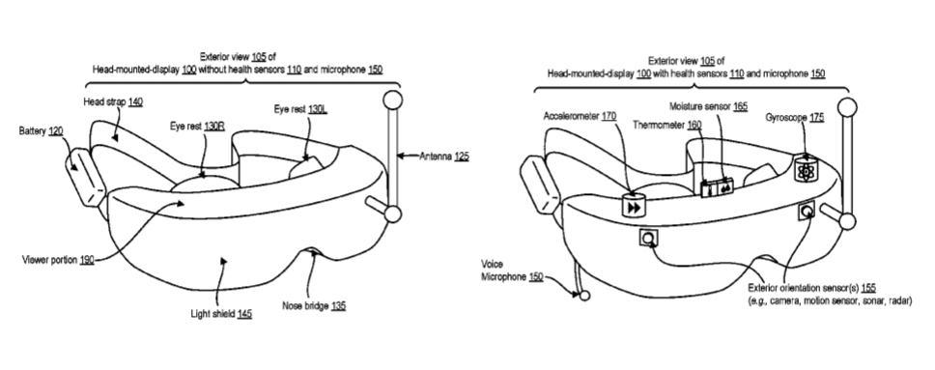

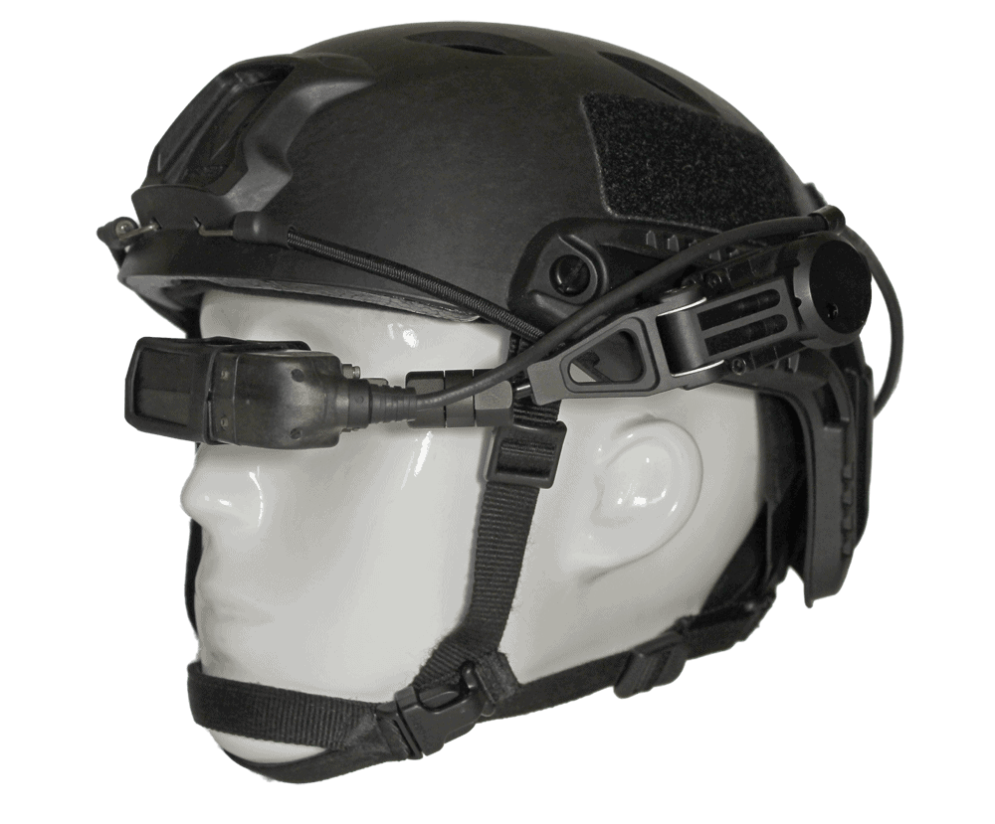

Figure 1: Diagram of a Head Mounted Radar

**Conclusion**

Security and safety for soldiers: - GPS tracks the position and monitors health parameters of soldiers which provides security and safety for soldiers. Continuous Communication is Possible. Soldiers can communicate with base station whenever in need. If soldier needs any help from base station then there is Panic button for emergency. So, tracking and navigation system is very useful for soldiers when they are on military field during war and also for base station, so that they can get real-time view of soldier’s on field displayed on PC.

**Recommendations**

The following recommendations are stated below:

1. That technology be used by military personnel so as to reduce the danger involved in military operations.
2. Technology be improved on so as to reduce or eliminate the disadvantages of the technology.

**References**

Adam, E. (2014). Tactical cockpits: the coming revolution. *IEEE AES Systems Magazine,* 9(1), 20-26.

Allison, R. S., Howard, I. & Zacher, J. E. (2009). Effect of field size, head motion, and rotational velocity on roll vection and illusory self-tilt in a tumbling room. *Perception,* 28(3), 299-306.

Amitai, Y., Friesem, A. & Weiss, V. (2008). New design of holographic helmet displays. *In Proceedings of Holographic Optics Design and Applications,* 88(3), 12-19.

Benson, A. J. & Barnes, G. R. (2008). Vision during angular oscillation: The dynamic interaction of visual and vestibular mechanisms. *Aviation, Space, and Environmental Medicine*, 49(2), 340-500.

Brickner, M. & Foyle, D. C. (2009). Field of view effects on a simulated flight task with head-down and head-up sensor imagery displays. In *Proceedings of the Human Factors Society 34th Annual Meeting,* 8(12), 1567-1571*.*

Clapp, R. E. (2017). Field of view, resolution, and brightness parameters for eye limited displays. In *Proceedings of SPIE: Imaging Sensors and Displays*, 765(1), 10-18*.*

Melzer, F. W. (2017). The depth of field of the human eye. *Optic Acta,* 4(1), 157-164*.*

Rash, C., Walsh, D. & Cornum, R. (2013). *Visual Survey of Apache Aviators*. [Technical Report USAARL 90-15]. Fort Rucker, AL: United States Army Aeromedical Research Laboratory.

Velger, B. (2008). Exploring a Colour Capable Helmet Mounted Display with built-in Eye Tracker. *An Empirical Study*, 13(2), 34-78.

Wong, E., Brown, J., Daye, H., Stice, R., Cariello, M., Ayres, J., Hook, L., Midthun, C., Gast, S., Wallace, F. & Reeves, M. (2014). Joint Visual System Operational Evaluation. *Advanced Fiber-Optic Helmet Mounted Display,* 13(1), 23-45.